**Week - 5**

**Microservices**

**Mandatory Hands-on**

**Creating Microservices for account and loan**

1. For Account

package com.cognizant.account;

import org.springframework.web.bind.annotation.*;

*@RestController*

*@RequestMapping*("/accounts")

public class AccountController {

*@GetMapping*("/{number}")

public Account getAccountByNumber(*@PathVariable* String number) {

return new Account(number, "Savings", 927642);

}

static class Account {

private String number;

private String type;

private double balance;

public Account(String number, String type, double balance) {

this.number = number;

this.type = type;

this.balance = balance;

}

public String getNumber() { return number; }

public void setNumber(String number) { this.number = number; }

public String getType() { return type; }

public void setType(String type) { this.type = type; }

public double getBalance() { return balance; }

public void setBalance(double balance) { this.balance = balance; }

}

}

package com.cognizant.account;

import org.springframework.boot.SpringApplication;

import org.springframework.boot.autoconfigure.SpringBootApplication;

*@SpringBootApplication*

public class AccountApplication {

public static void main(String[] args) {

SpringApplication.*run*(AccountApplication.class, args);

}

}

Console:

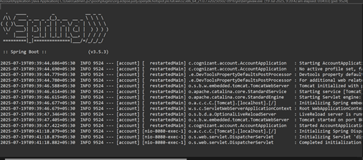

Output:

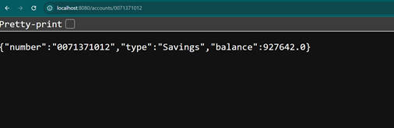

1. For loan

package com.cognizant.loan;

import org.springframework.web.bind.annotation.*;

*@RestController*

*@RequestMapping*("/loans")

public class LoanController {

*@GetMapping*("/{loanNumber}")

public Loan getLoanDetails(*@PathVariable* String loanNumber) {

return new Loan(loanNumber, "Personal", 280000, 7.5);

}

static class Loan {

private String loanNumber;

private String type;

private double amount;

private double interestRate;

public Loan(String loanNumber, String type, double amount, double interestRate) {

this.loanNumber = loanNumber;

this.type = type;

this.amount = amount;

this.interestRate = interestRate;

}

public String getLoanNumber() { return loanNumber; }

public void setLoanNumber(String loanNumber) { this.loanNumber = loanNumber; }

public String getType() { return type; }

public void setType(String type) { this.type = type; }

public double getAmount() { return amount; }

public void setAmount(double amount) { this.amount = amount; }

public double getInterestRate() { return interestRate; }

public void setInterestRate(double interestRate) { this.interestRate = interestRate; }

}

}

package com.cognizant.loan;

import org.springframework.boot.SpringApplication;

import org.springframework.boot.autoconfigure.SpringBootApplication;

*@SpringBootApplication*

public class LoanApplication {

public static void main(String[] args) {

SpringApplication.*run*(LoanApplication.class, args);

}

}

. ____ _ __ _ _

/\\ / ___'_ __ _ _(_)_ __ __ _ \ \ \ \

( ( )\___ | '_ | '_| | '_ \/ _` | \ \ \ \

\\/ ___)| |_)| | | | | || (_| | ) ) ) )

' |____| .__|_| |_|_| |_\__, | / / / /

=========|_|==============|___/=/_/_/_/

:: Spring Boot :: (v3.5.3)

2025-07-19T12:55:27.429+05:30 INFO 6964 --- [loan] [ restartedMain] com.cognizant.loan.LoanApplication : Starting LoanApplication using Java 21.0.7 with PID 6964 (D:\7282\microservices\loan\target\classes started by admin in D:\7282\microservices\loan)

2025-07-19T12:55:27.435+05:30 INFO 6964 --- [loan] [ restartedMain] com.cognizant.loan.LoanApplication : No active profile set, falling back to 1 default profile: "default"

2025-07-19T12:55:27.541+05:30 INFO 6964 --- [loan] [ restartedMain] .e.DevToolsPropertyDefaultsPostProcessor : Devtools property defaults active! Set 'spring.devtools.add-properties' to 'false' to disable

2025-07-19T12:55:27.542+05:30 INFO 6964 --- [loan] [ restartedMain] .e.DevToolsPropertyDefaultsPostProcessor : For additional web related logging consider setting the 'logging.level.web' property to 'DEBUG'

2025-07-19T12:55:29.172+05:30 INFO 6964 --- [loan] [ restartedMain] o.s.b.w.embedded.tomcat.TomcatWebServer : Tomcat initialized with port 8080 (http)

2025-07-19T12:55:29.196+05:30 INFO 6964 --- [loan] [ restartedMain] o.apache.catalina.core.StandardService : Starting service [Tomcat]

2025-07-19T12:55:29.197+05:30 INFO 6964 --- [loan] [ restartedMain] o.apache.catalina.core.StandardEngine : Starting Servlet engine: [Apache Tomcat/10.1.42]

2025-07-19T12:55:29.247+05:30 INFO 6964 --- [loan] [ restartedMain] o.a.c.c.C.[Tomcat].[localhost].[/] : Initializing Spring embedded WebApplicationContext

2025-07-19T12:55:29.250+05:30 INFO 6964 --- [loan] [ restartedMain] w.s.c.ServletWebServerApplicationContext : Root WebApplicationContext: initialization completed in 1703 ms

2025-07-19T12:55:29.781+05:30 INFO 6964 --- [loan] [ restartedMain] o.s.b.d.a.OptionalLiveReloadServer : LiveReload server is running on port 35729

2025-07-19T12:55:29.834+05:30 INFO 6964 --- [loan] [ restartedMain] o.s.b.w.embedded.tomcat.TomcatWebServer : Tomcat started on port 8080 (http) with context path '/'

2025-07-19T12:55:29.847+05:30 INFO 6964 --- [loan] [ restartedMain] com.cognizant.loan.LoanApplication : Started LoanApplication in 3.082 seconds (process running for 3.789)

2025-07-19T12:56:02.053+05:30 INFO 6964 --- [loan] [nio-8080-exec-1] o.a.c.c.C.[Tomcat].[localhost].[/] : Initializing Spring DispatcherServlet 'dispatcherServlet'

2025-07-19T12:56:02.053+05:30 INFO 6964 --- [loan] [nio-8080-exec-1] o.s.web.servlet.DispatcherServlet : Initializing Servlet 'dispatcherServlet'

2025-07-19T12:56:02.055+05:30 INFO 6964 --- [loan] [nio-8080-exec-1] o.s.web.servlet.DispatcherServlet : Completed initialization in 2 ms

Output:

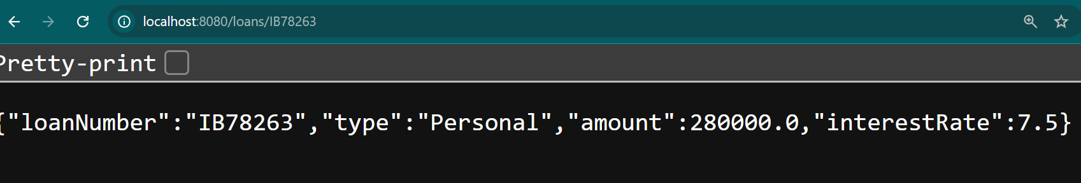

**Additional Hands-on**

**Create Eureka Discovery Server and register microservices**

**Localhost:8761**

